**AWT PRACTICAL-3 PRODUCT API**

Implementation

Part-1

1. Create API
   1. Use JSON file which contains various products details such as product_id, product_name, product_type, product_image, product_quantity, product_cost and description.
   2. Create 5 products sets in JSON.
2. Display all product information on console and also on client browser. [ Create server first]
3. Define following routes to access page.
   1. localhost/ [Bydefault display default page as below]
   2. localhost/default
   3. localhost/api
   4. localhost/product
   5. localhost/product?id=0 [By default]
   6. localhost/anyother then display page not found with status code.

Part-2 [HTML template/placeholder] - Define placeholder and replace by the content dynamically

1. Create HTML temples for 1. Default page 2. Product page and 3. CardInfo page
   1. Default page: Display products information from JSON such as ID, Name, Type and Price in different cards/sections [You may use DIV/FIGURE]
   2. Default page contain tag like **20% Discount**on some specific products.
   3. Default page contain link like **more details to** view individual product information [Display remaining info from JSON]
   4. All the individual product with respective cards should be accessible using URI like localhost/product?id=0 and so on.
   5. Use proper CSS style or any bootstrap theme.
2. Upload Instruction: PDF file with code and screenshots of each output.

**Index.js**

const fs = require('fs');

const http = require('http');

const url = require('url');

const replaceTemplate = (temp, product) => {

    let output = temp.replace(/{%PRODUCTNAME%}/g, product.productName);

    output = output.replace(/{%IMAGE%}/g, product.image);

    output = output.replace(/{%PRICE%}/g, product.price);

    output = output.replace(/{%FROM%}/g, product.from);

    output = output.replace(/{%TYPE%}/g, product.type);

    output = output.replace(/{%QUANTITY%}/g, product.quantity);

    output = output.replace(/{%DESCRIPTION%}/g, product.description);

    output = output.replace(/{%ID%}/g, product.id);

    if(!product.discount) output = output.replace(/{%NOT_DISCOUNT%}/g, 'not-discount');

    return output;

}

const tempOverview = fs.readFileSync(`${__dirname}/final/templates/template-overview.html`, 'utf-8');

const tempCard = fs.readFileSync(`${__dirname}/final/templates/template-card.html`, 'utf-8');

const tempProduct = fs.readFileSync(`${__dirname}/final/templates/template-product.html`, 'utf-8');

const data = fs.readFileSync(`${__dirname}/final/jsondata/data.json`, 'utf-8');

const dataObj = JSON.parse(data);

//Create Server

const server = http.createServer((req, res) => {

    const { query, pathname } = url.parse(req.url, true);

    //console.log(req.url);

    //console.log(url.parse(req.url, true));

    //const pathName = req.url;

    // Overview page

    if(pathname === '/' || pathname === '/overview'){

        res.writeHead(200, { 'Content-type': 'text/html'})

        const cardsHtml = dataObj.map(el => replaceTemplate(tempCard, el));

        const output = tempOverview.replace('{%PRODUCT_CARDS%}', cardsHtml);

        res.end(output);

    // Product page

    } else if (pathname === '/product'){

        res.writeHead(200, { 'Content-type': 'text/html'});

        const product = dataObj[query.id];

        const output = replaceTemplate(tempProduct, product);

        res.end(output);

    // API page

    }else if(pathname === '/api'){

        res.writeHead(200, { 'Content-type': 'application/json' })

        res.end(data);

    // Not found

    }else{

        res.writeHead(404,{

            'Content-type': 'text/html',

            'my-own-header': '404Error'

        });

        res.end("<h1>404 Error</h1>");

    }

});

// Server Listening

server.listen(8000, '127.0.0.1', ()=>{

    console.log('Listening request on port 8000');

});

**data.json**

[

  {

    "id": 0,

    "productName": "T-Shirts",

    "image": "👕",

    "from": "Spain",

    "type": "2 Full-Sleeves, 2 Half-Sleeves ",

    "quantity": "4 👕",

    "price": "1500",

    "discount": true,

    "description": "Preshrunk to let the size fit you perfectly,ﾠMore breathability and resistant with combed yarn and soft feel of cotton, 60 degree color fastness for the bold and bright look, Sustainable colors ensuring long-lastingness."

  },

  {

    "id": 1,

    "productName": "Jeans",

    "image": "👖",

    "from": "Portugal",

    "type": "1 Skinny jeans (Tight jeans), 1 Straight leg jeans",

    "quantity": "2 👖",

    "price": "2000",

    "discount": false,

    "description": "Shop from a wide range of Jeans from Guchu. Perfect for your everyday use, you could pair it with a stylish t-shirt or shirt complete the look."

  },

  {

    "id": 2,

    "productName": "Shirts",

    "image": "👔",

    "from": "Portugal",

    "type": "3 Formal Shirts",

    "quantity": "3 👔",

    "price": "5000",

    "discount": true,

    "description": "Red and black checked casual shirt, has a spread collar, button placket, 1 pocket, long sleeves, curved hem."

  },

  {

    "id": 3,

    "productName": "Shorts",

    "image": "🩳",

    "from": "USA",

    "type": "4 Puma Shorts",

    "quantity": "4 🩳",

    "price": "2000",

    "discount": true,

    "description": "Black solid mid-rise lounge shorts, has an inner elasticated with outer drawstring closure, two pockets."

  },

  {

    "id": 4,

    "productName": "Sari",

    "image": "🥻",

    "from": "Varanasi",

    "type": "2 Banarasi Sari",

    "quantity": "2 🥻",

    "price": "8000",

    "discount": false,

    "description": "Teal and Gold-toned banarasi woven design saree and has a woven design border.Banarasi sarees originate from the city of Varanasi (Uttar Pradesh). These are well known for the Mughal Era inspired designs in golden as well as silver brocade or Zari."

  }

]

**template-overview.html**

<!DOCTYPE html>

<html lang="en">

  <head>

    <meta charset="UTF-8" />

    <meta name="viewport" content="width=device-width, initial-scale=1.0" />

    <meta http-equiv="X-UA-Compatible" content="ie=edge" />

    <link

      rel="icon"

      href="https://emojipedia-us.s3.dualstack.us-west-1.amazonaws.com/thumbs/160/google/110/convenience-store_1f3ea.png"

    />

    <link

      rel="stylesheet"

      href="https://bootswatch.com/5/morph/bootstrap.min.css"

    />

    <title>Fashion MAll</title>

    <style>

      *,

      *::before,

      *::after {

        margin: 0;

        padding: 0;

        box-sizing: inherit;

      }

      body{

         background-color: #ffffff;

background-image: url("data:image/svg+xml,%3Csvg xmlns='http://www.w3.org/2000/svg' width='160' height='160' viewBox='0 0 200 200'%3E%3Cpolygon fill='%23DCEFFA' points='100 0 0 100 100 100 100 200 200 100 200 0'/%3E%3C/svg%3E");

      }

      .card__detail--discount {

        font-weight: 900;

        text-transform: uppercase;

        font-size: 1rem;

        background-image: linear-gradient(to right, #9be15d, #00e3ae);

        -webkit-background-clip: text;

        background-clip: text;

        color: transparent;

      }

      .not-discount {

        display: none;

      }

      .mainbox {

        margin: 2rem auto;

      }

      .cardn{

        margin:0.5rem auto;

      }

    </style>

  </head>

  <body>

    <div class="container-fluid mainbox">

      <div class="row justify-content-md-center">

        <div class="col-md-auto">

          <h1>🏪 Fashion MALL 🏬</h1>

        </div>

      </div>

      <div class="container main2">{%PRODUCT_CARDS%}</div>

    </div>

  </body>

</html>

**template-product.html**

<!DOCTYPE html>

<html lang="en">

  <head>

    <meta charset="UTF-8" />

    <meta name="viewport" content="width=device-width, initial-scale=1.0" />

    <meta http-equiv="X-UA-Compatible" content="ie=edge" />

    <link

      rel="icon"

      href="https://emojipedia-us.s3.dualstack.us-west-1.amazonaws.com/thumbs/160/google/110/convenience-store_1f3ea.png"

    />

    <link

      rel="stylesheet"

      href="https://bootswatch.com/5/morph/bootstrap.min.css"

    />

    <title>{%PRODUCTNAME%} {%IMAGE%}</title>

    <style>

      *,

      *::before,

      *::after {

        margin: 0;

        padding: 0;

        box-sizing: inherit;

      }

      body{

         background-color: #ffffff;

background-image: url("data:image/svg+xml,%3Csvg xmlns='http://www.w3.org/2000/svg' width='160' height='160' viewBox='0 0 200 200'%3E%3Cpolygon fill='%23DCEFFA' points='100 0 0 100 100 100 100 200 200 100 200 0'/%3E%3C/svg%3E");

      }

      a{

        text-decoration: none;

      }

      .product__hero {

        position: relative;

        height: 22rem;

        overflow: hidden;

      }

      .product__hero::before {

        content: '';

        display: block;

        height: 100%;

        width: 100%;

        position: absolute;

        top: 0;

        left: 0;

        background-image: linear-gradient(to left bottom, #c1ceb6, #3f4644);

        opacity: 0.5;

        z-index: 100;

      }

      .product__emoji {

        font-size: 15rem;

        position: absolute;

      }

      .product__emoji--1 {

        top: -4rem;

        left: -2rem;

        z-index: 10;

      }

      .product__emoji--2 {

        top: -6rem;

        left: 9rem;

      }

      .product__emoji--3 {

        top: -4rem;

        right: 15rem;

      }

      .product__emoji--4 {

        top: -5rem;

        right: 2rem;

        z-index: 10;

      }

      .product__emoji--5 {

        bottom: -9rem;

        left: 18rem;

      }

      .product__emoji--6 {

        bottom: -8rem;

        left: 5rem;

      }

      .product__emoji--7 {

        bottom: -12rem;

        right: 14rem;

      }

      .product__emoji--8 {

        bottom: -8rem;

        right: -2rem;

      }

      .product__emoji--9 {

        top: -7rem;

        left: 19rem;

      }

      .not-discount {

        display: none;

      }

      .mainbox {

        margin: 2rem auto;

        padding:1rem auto;

      }

      .dis{

        margin-left: 50%;

      }

    </style>

  </head>

  <body>

    <div class="container mainbox">

      <div class="row justify-content-md-center">

        <div class="col-md-auto">

          <h1>🏪 Fashion MALL 🏬</h1>

        </div>

      </div>

      <div class="row justify-content-md-center">

      <div class="card mb-3" style="width: 40rem;">

        <h3 class="card-header">

          {%PRODUCTNAME%}

          <div class="btn btn-warning disabled dis {%NOT_DISCOUNT%}"><h5><strong>20% Discount</strong></h5></div>

        </h3>

        <div class="card-body">

        <a href="/overview" class="btn btn-info">

          <span class="emoji-left">👈</span>Back

        </a>

        </div>

        <div class="product__hero">

          <span class="product__emoji product__emoji--1">{%IMAGE%}</span>

          <span class="product__emoji product__emoji--2">{%IMAGE%}</span>

          <span class="product__emoji product__emoji--3">{%IMAGE%}</span>

          <span class="product__emoji product__emoji--4">{%IMAGE%}</span>

          <span class="product__emoji product__emoji--5">{%IMAGE%}</span>

          <span class="product__emoji product__emoji--6">{%IMAGE%}</span>

          <span class="product__emoji product__emoji--7">{%IMAGE%}</span>

          <span class="product__emoji product__emoji--8">{%IMAGE%}</span>

          <span class="product__emoji product__emoji--9">{%IMAGE%}</span>

        </div>

        <div class="card-body">

          <p class="card-text">{%DESCRIPTION%}</p>

        </div>

        <ul class="list-group list-group-flush">

          <li class="list-group-item"><span class="emoji-left">🌍</span>From {%FROM%}</li>

          <li class="list-group-item"><span class="emoji-left">❤️</span>{%TYPE%}</li>

          <li class="list-group-item">{%QUANTITY%} <span class="emoji-left">Combo 🔥</span></li>

          <li class="list-group-item"><span class="emoji-left">🏷️</span>{%PRICE%} ₹</li>

        </ul>

        <div class="card-footer text-muted">

        </div>

      </div>

    </div>

    </div>

  </body>

</html>

**template-overview.html**

  <div class="row justify-content-md-center cardn">

    <div class="card border-info mb-3" style="max-width: 20rem;">

      <div class="card-header">&nbsp;&nbsp;&nbsp;&nbsp;{%PRODUCTNAME%}&nbsp;&nbsp;&nbsp;&nbsp;{%IMAGE%}{%IMAGE%}</div>

      <div class="card-body">

        <h4 class="card-title">

          <div class="card__detail-box {%NOT_DISCOUNT%}">

            <h6 class="card__detail card__detail--discount">20% Discount</h6>

         </div>

        </h4>

        <p class="card-text">{%QUANTITY%} Combo 🔥</p>

        <p class="card-text">{%PRICE%} ₹</p>

        <p class="card-text">{%TYPE%}</p>

        <p class="card-text">

          <a class="btn btn-outline-secondary" href="/product?id={%ID%}">

            <span>Detail <i class="emoji-right">👉</i></span>

          </a>

        </p>

      </div>

    </div>

  </div>

**OUTPUT**

**localhost/api**

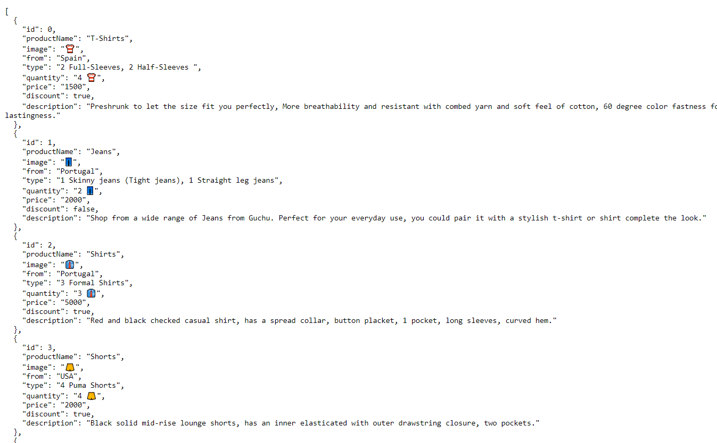

**localhost:8000/**

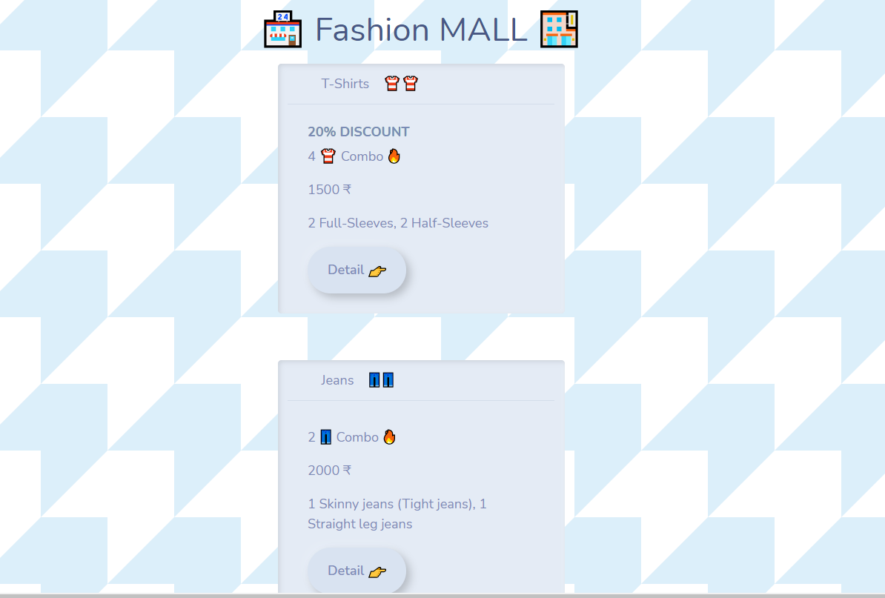

**localhost:8000/product?id=0**

